NAME:MEGHANA GANESH
REG NO.:210905160
CSE A

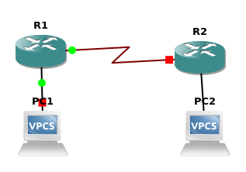

II.
LAB EXERCISES
1. Switching Cisco IOS Command Modes
This exercise demonstrates how to log into a router and how to work with the different Cisco
IOS command modes. It is important to understand the different modes so you know where you
are and what commands are accepted at any time.
i. Connect the Ethernet interfaces of the Linux PCs and the Cisco router as shown in Figure 6.7.
Do not turn on the Linux PCs yet.
ii. Right-click on Router1 and choose Start.
iii. Right-click on Router1 and choose Console. Wait a few seconds until the router is initialized.
If everything is fine, you should see the prompt shown below. This is the User EXEC mode. If
the prompt does not appear, try to restart GNS3 and repeat the setup again.
Router1>
iv. To see which commands are available in this mode, type ?:
Router1>?
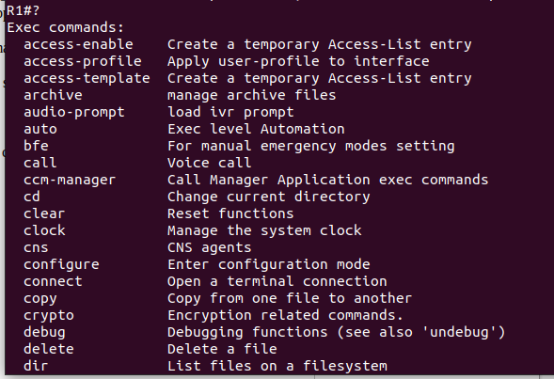
v. To view and change system parameters of a Cisco router, you must enter the Privileged EXEC
mode by typing:
Router1>enable
Router1#
vi. Type the following command to disable the Privileged EXEC mode
Router1# disable

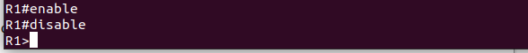

vii. To modify system wide configuration parameters, you must enter the global configuration
mode. This mode is entered by typing:
Router1#configure terminal
Router1(config)#
or
Router1#conf t
Router1(config)#
viii. To make changes to a network interface, enter the interface configuration mode, with the
command:
Router1(config)#interface FastEthernet0/0
Router1(config-if)#
The name of the interface is provided as an argument. Here, the network interface that is
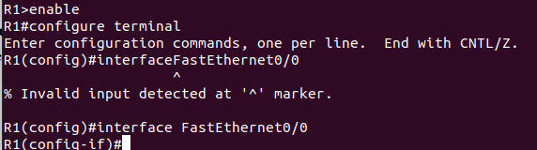
configured is FastEthernet0/0.

ix. To return from the interface configuration to the global configuration mode, or from the
global configuration mode to the Privileged EXEC mode, use the exit command:
Router1(config-if)#exit
Router1(config)#exit
Router1#
The exit command takes you one step up in the command hierarchy. To directly return to the
Privileged EXEC mode from any configuration mode, use the end command:
Router1(config-if)#end
Router1#

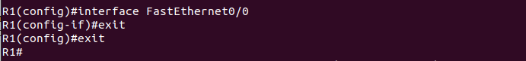

x. To terminate the console session from the User EXEC mode, type logout or exit:
Router1>logout
Router con0 is now available
Press RETURN to get started

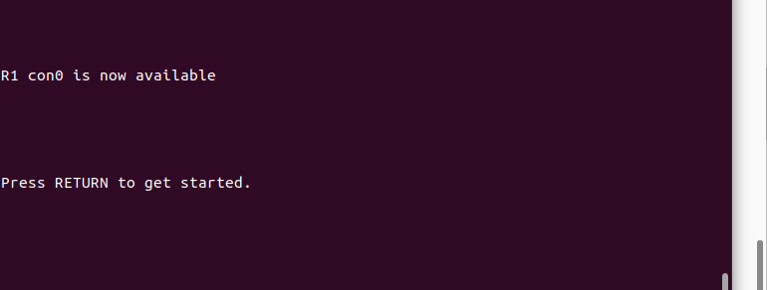

2. Configuring a Cisco Router via the console
The following exercises use basic commands from the Cisco IOS that are needed to configure a
Cisco router.
i. Right-click on Router1 and choose Start.
ii. Right-click on Router1 and choose Console. Wait some seconds until the initial console
window is set up. When the router is ready to receive commands, proceed to the next step.
iii. Configure Router1 and Router 2 with the IP addresses given in Figure 6.7.

In Router 1
Interface Fastethernet0/0 in global configuration mode
R1(config)#inter f 0/0
R1(config-if)#ip address 10.0.0.1 255.0.0.0
R1(config-if)#no shutdown
R1(config-if)#exit
Interface Serial 2/0
R1(config)#inter s2/0
R1(config-if)#ip address 20.0.0.1 255.0.0.0
R1(config-if)#clock rate 64000
R1(config-if)#encapsulation ppp
R1(config-if)#no shutdown
R1(config-if)#exit

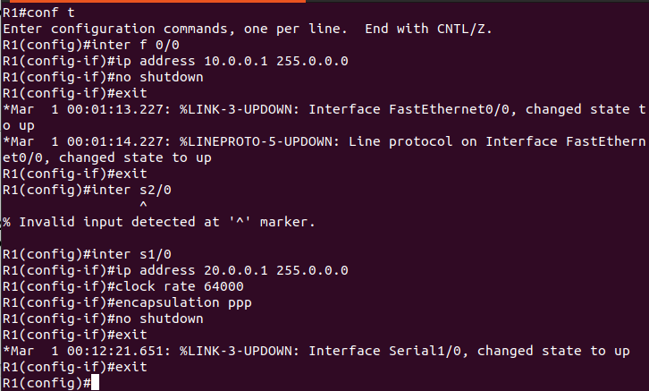

In Router 2
Interface Fastethernet 0/0
R2(config)#inter f0/0
R2(config-if)#ip address 30.0.0.1 255.0.0.0
R2(config-if)#no shutdown
R2(config-if)#exit
Interface Serial 2/0
R2(config)#inter s2/0
R2(config-if)#ip address 20.0.0.2 255.0.0.0
R2(config-if)#encapsulation ppp
R2(config-if)#no shutdown
R2(config-if)#exit

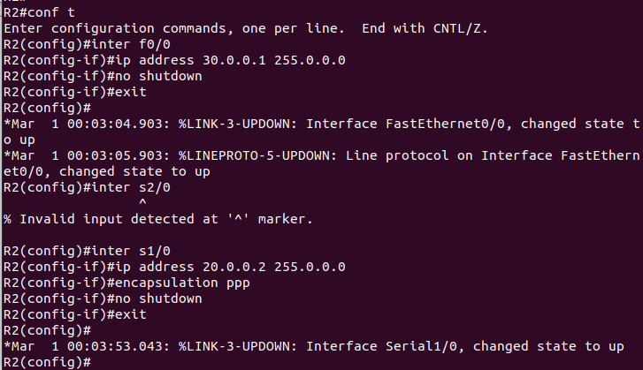

iv. When you are done, use the following command to check the changes you made to the router
configuration, and save the outputs:
R1# show interfaces
R1#show running-config

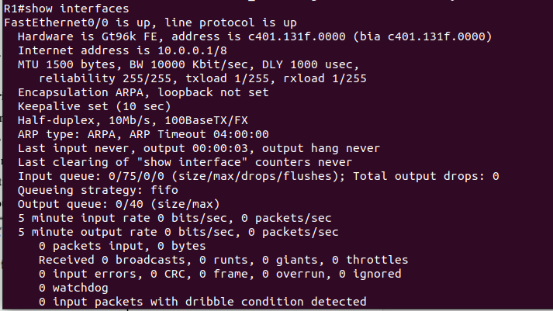

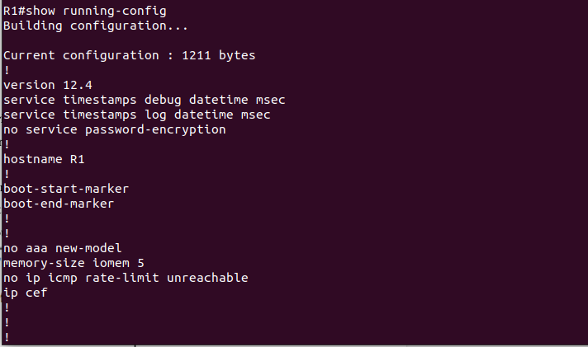

v. Assign ip addresses for both PC's as mentioned in Figure 6.7 with appropriate ip and subnet
maskand default gateway.

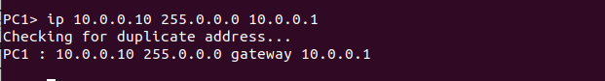
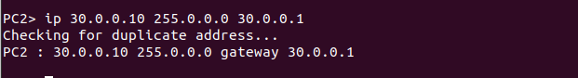

3. Setting static routing table entries on a Cisco router
In this exercise, you will add static routes to the routing table of Router1. The routing table must
be configured so that it conforms to the network topology shown in Figure 6.7. The routes are
configured manually, which is also referred to as static routing.
The IOS command to configure static routing is ip route. The command can be used to show,
clear, add, or delete entries in the routing table. The commands are summarized in the list below.

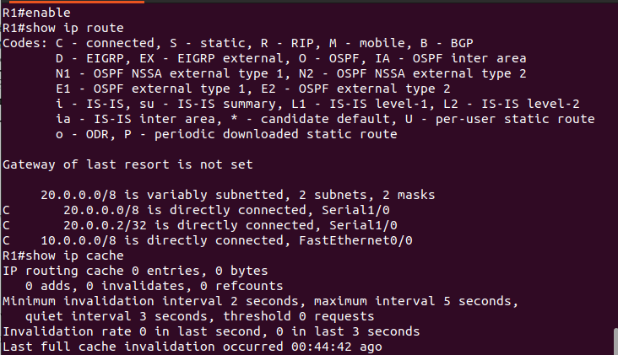

By default, Routers know only directed connected networks here Router 1 know only 10.0.0.0
and 20.0.0.0 it doesn't know the 30.0.0.0 like this R2 doesn't know about 10.0.0.0.So we are
going to add Static route to this both router.
R1(config)#ip route Destination Network| Destination N/W Subnet Mask |Next Hop
Address
In Router R1, just give this command, in this case Destination is 30.0.0.0 and its subnet mask is
255.0.0.0 next hop address is 20.0.0.2
R1(config)#ip route 30.0.0.0 255.0.0.0 20.0.0.2
In Router R2
R2(config)#ip route 10.0.0.0 255.0.0.0 20.0.0.1

Now both routers know all the networks.
i. Issue a ping command from PC1 to PC2, Router1 and Router2, respectively
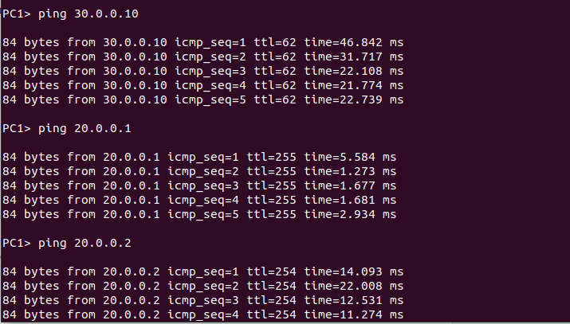

Now both routers know all the networks.
i. Issue a ping command from PC1 to PC2, Router1 and Router2, respectively
ii. Save the captured Wireshark output.
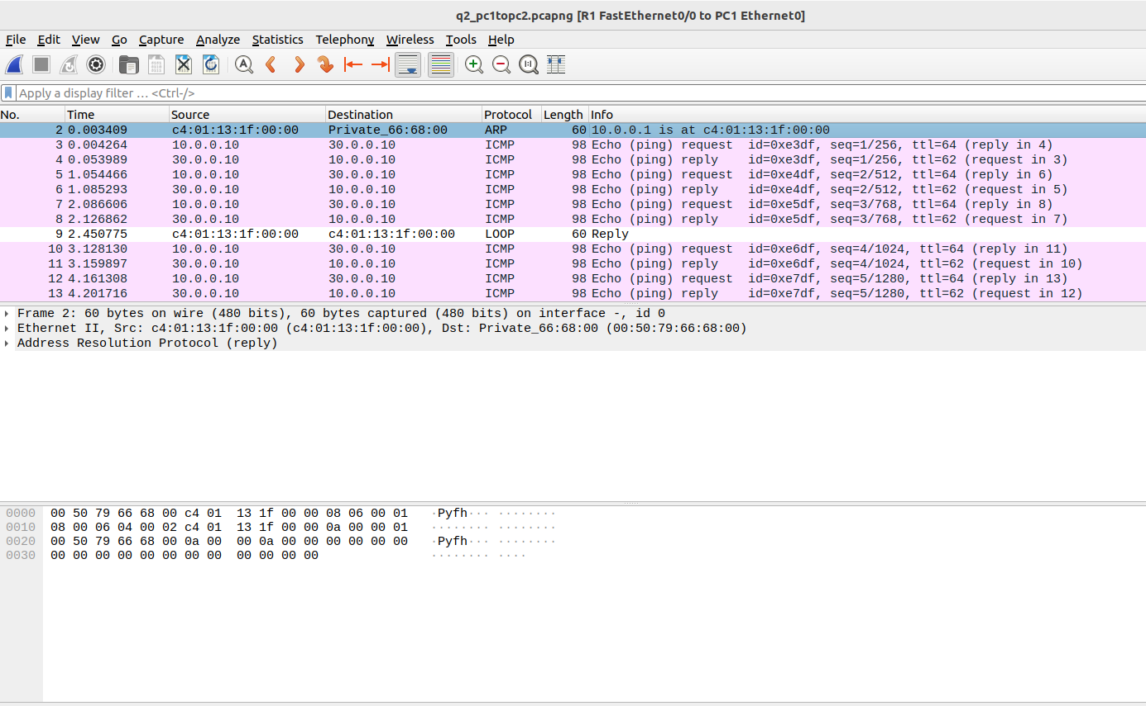
PC1 TO PC2
PC1 TO R2
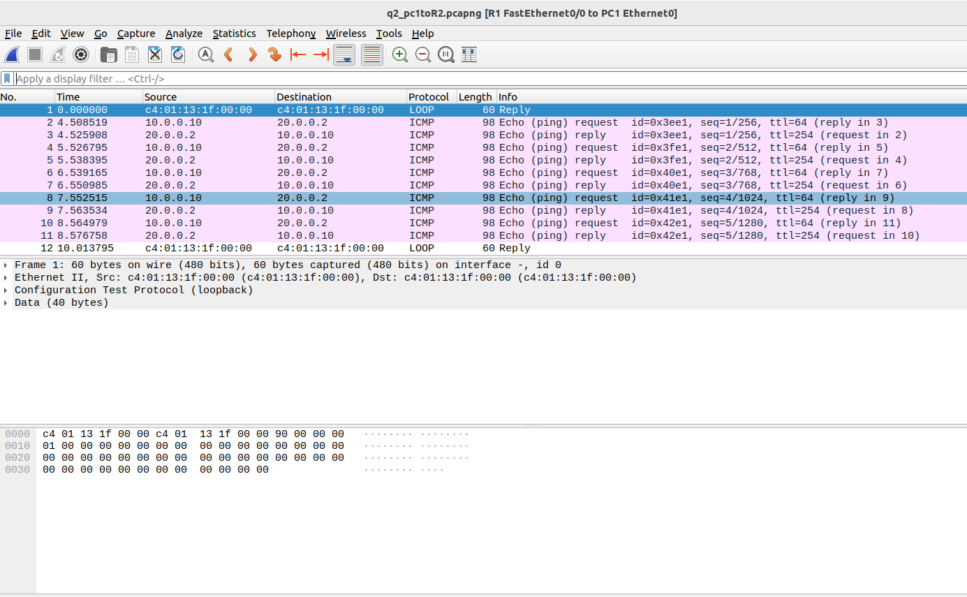

PC1 TO R1

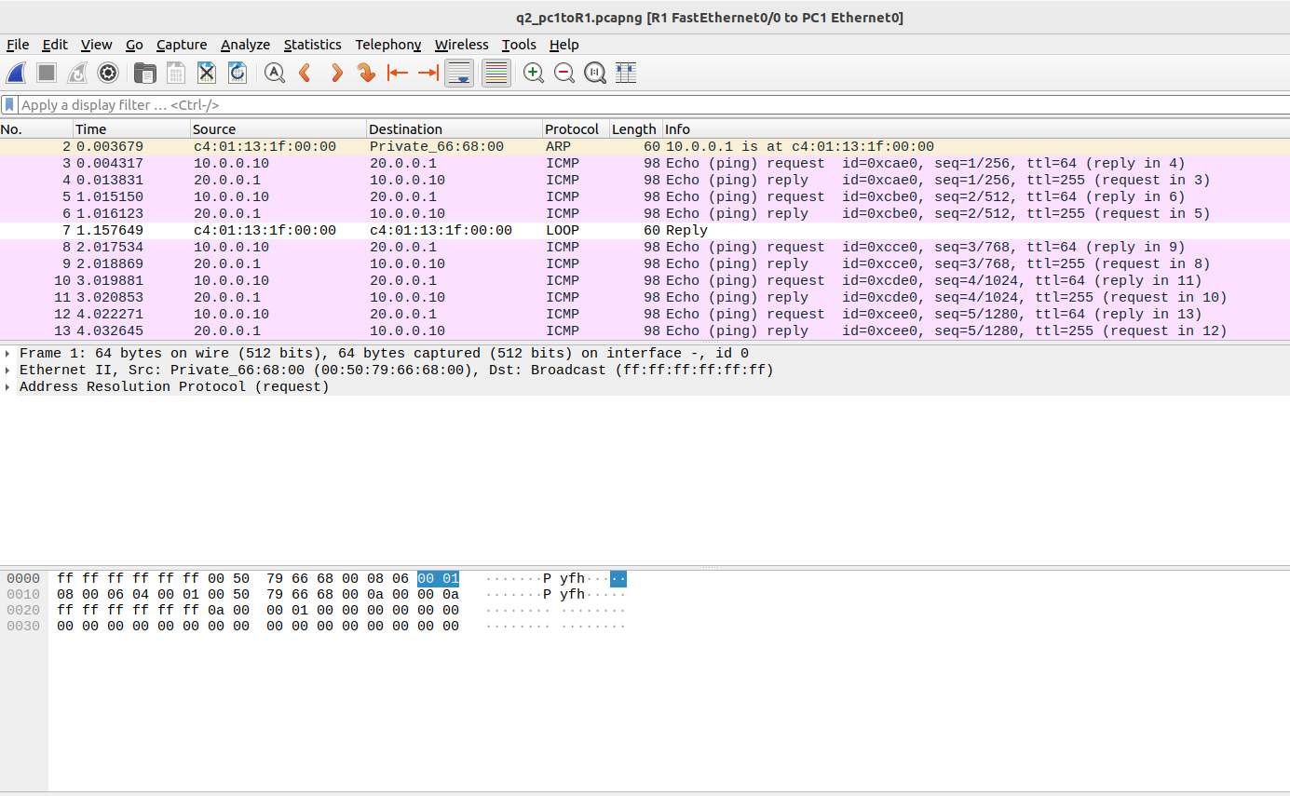

• What is the output on PC1 when the ping commands are issued?
PC1 should have successful pings to PC2, Router1, and Router2, assuming that the configurations and routes are correct. If the ping commands were successful, you should see responses indicating that the destinations are reachable.
• Which packets, if any, are captured by Wireshark?
ARP,ICMP packets.
• Do you observe any ARP packets? If so, what do they indicate?
Yes.ARP packets are used to map IP addresses to MAC addresses in a local network.
ARP Request: PC1 may send ARP requests to resolve the MAC address of the default gateway (Router1). These ARP requests ask, "Who has the IP address 10.0.0.1?" The ARP request should be directed to the local network's broadcast address (e.g., 10.0.0.255).
- ARP Reply: Router1, which has the IP address 10.0.0.1, should reply to the ARP request with its MAC address. This reply enables PC1 to send packets to Router1, knowing its MAC address.
- ARP Requests between Router1 and Router2: If Router1 and Router2 are directly connected via a serial link, you might also see ARP requests and replies between them, allowing them to learn each other's MAC addresses for communication on the serial link.

II.In the CSE department, two students sitting in two different labs want to establish a
connection and send the data. So, configure the below network topology as shown in Figure.
6.8 and check the connectivity by pinging from PC0 to PC2.

